

**North South University**

**EEE 111**

**ANALOG ELECTRONICS**

**PROJECT PROPOSAL**

**SUBMITTED BY:** Team ***REVOLUTION***



Section: 11

**SUBMITTED TO:**

Course Instructor’s Name: NEETHILA NABANITA PODDAR

Course Instructor’s Initial: NNP

**Project Name: ALARM SYSTEM USING ARDUINO.**

**Project Introduction:**

The alarm system is small compared to the ones used in industries and also those which are used in homes too. The system can detect movement and start the alarm if an intruder comes near.

**Summary of Procedure:**

First and foremost, the circuit needs to be completed on the breadboard. Then we will connect it with the Arduino. TRIG is the pin used to send a sonar signal and ECHO is used to read the signal back and therefore calculate the distance. Last but not the least the necessary code needs to be uploaded to the board in order for to work properly.

**Uses of The Circuit:**

Currently the use of IOT devices has grown in number and in popularity. People are using IOT devices in everyday life and adding a touch of automation in their lives. Arduino is also in the family of IOT devices. It’s cheap, easy to program and easy to use. Our main goal is to create an alarm system which is very easy to build and it can also be used in your home, also in your room.

**Components:**

1. Arduino Uno

2. Ultrasonic Sensor HC-SR04

3. Buzzer

4. Red led

5. Breadboard

6. Jumper Wire

**Circuit Diagram:**

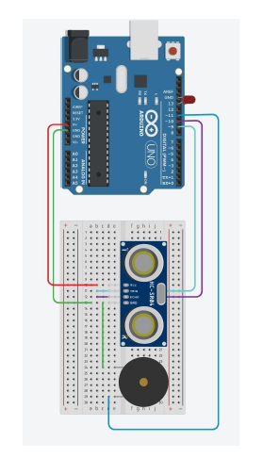

So, if we follow all the steps and do our work precisely our project will be completed. Hopefully, we will make a great project.

|  |  |
| --- | --- |
|  |  |
|  |  |